Prime Ring Problem

A ring is composed of n circles as shown in diagram. Put natural number 1, 2, ..., n into each circle separately, and the sum of numbers in two adjacent circles should be a prime.
Note: the number of first circle should always be 1.
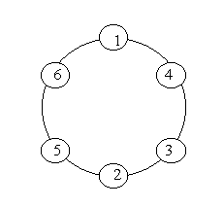
Input
n (0 < n < 20)

Output
The output format is shown as sample below. Each row represents a series of circle numbers in the ring beginning from 1 clockwisely and anticlockwisely. The order of numbers must satisfy the above requirements. Print solutions in lexicographical order.
You are to write a program that completes above process.
Print a blank line after each case.

Sample Input
6
8

Sample Output
Case 1:
1 4 3 2 5 6
1 6 5 2 3 4

Case 2:
1 2 3 8 5 6 7 4
1 2 5 8 3 4 7 6
1 4 7 6 5 8 3 2
1 6 7 4 3 8 5 2

